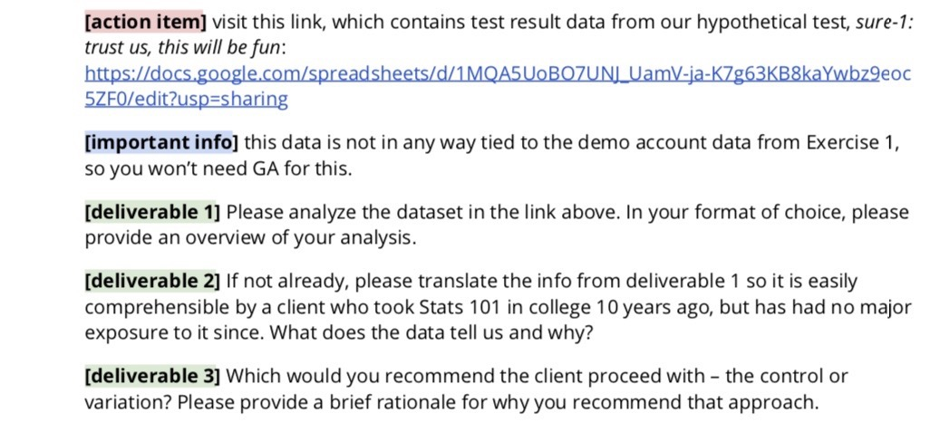

**Deliverable 1**

The overview upon analysis is that there are no considerable changes between the test and control period for various graphs plotted for Revenue, Users, Sessions and Transactions between control and test periods for mobile and desktop device during the period of Oct 18th and Oct 31st.

**Deliverable 2**

With the data for control and test period for Desktop and Mobile, various graphs were plotted during the period of Oct 18th and Oct 31st.

1. The best fit line is the same for both control and test period. The best fit line is a straight line that best represents the data.

Following figures show variation of Revenue, Transactions and Sessions with Days Index is the same between

* test (sure-1-v1 desktop) and control (sure-1-v0 desktop) of Desktop
* test (sure-1-v1 mobile) and control (sure-1-v0 mobile) of Mobile

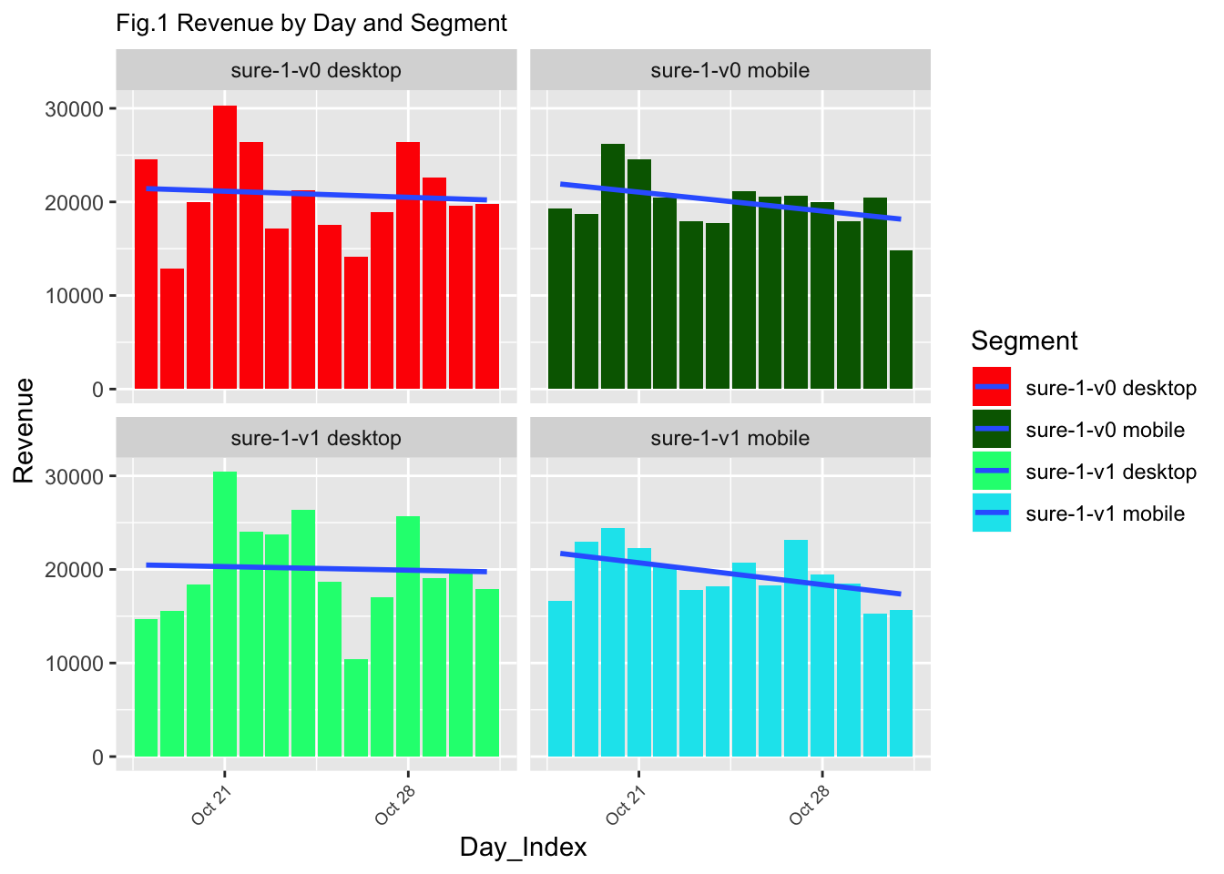



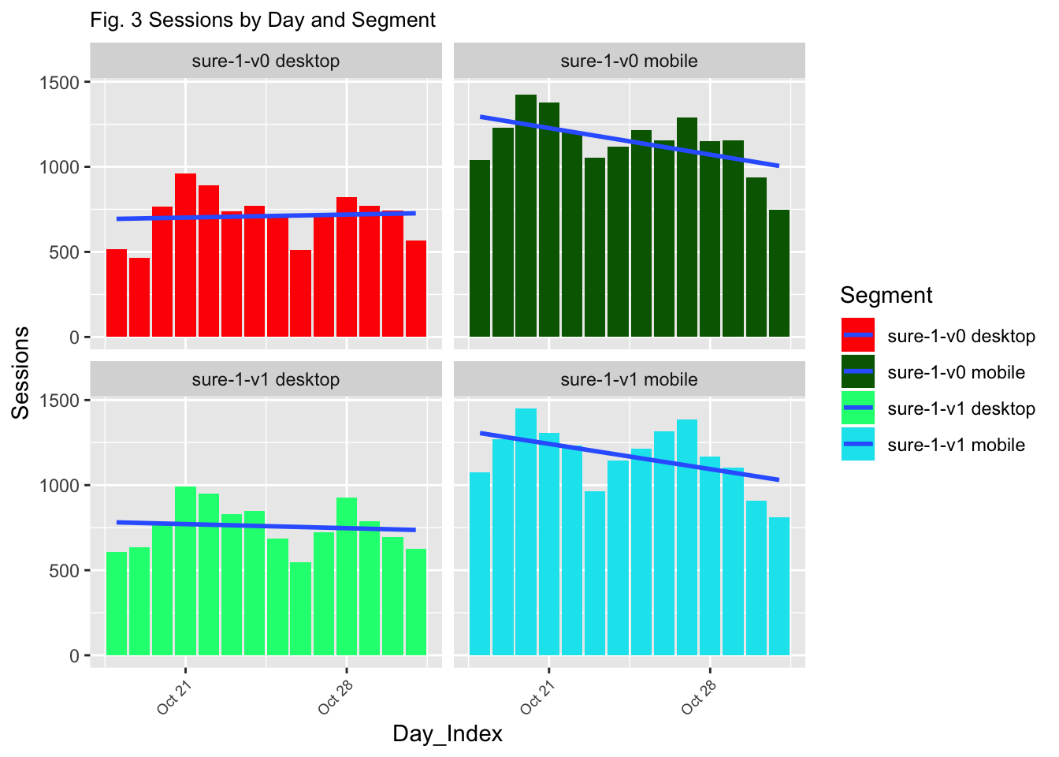

Following figures show variation of Revenue for Transactions, Sessions and Users and it is the same between

* test (sure-1-v1 desktop) and control (sure-1-v0 desktop) of Desktop
* test (sure-1-v1 mobile) and control (sure-1-v0 mobile) of Mobile



1. The Box plot shows that mean remains the same in the control (sure-1-v0 ) and test (sure-1-v1) period for Desktop and Mobile respectively plotted for Days-Index versus Revenue, Transactions, Users and Sessions.

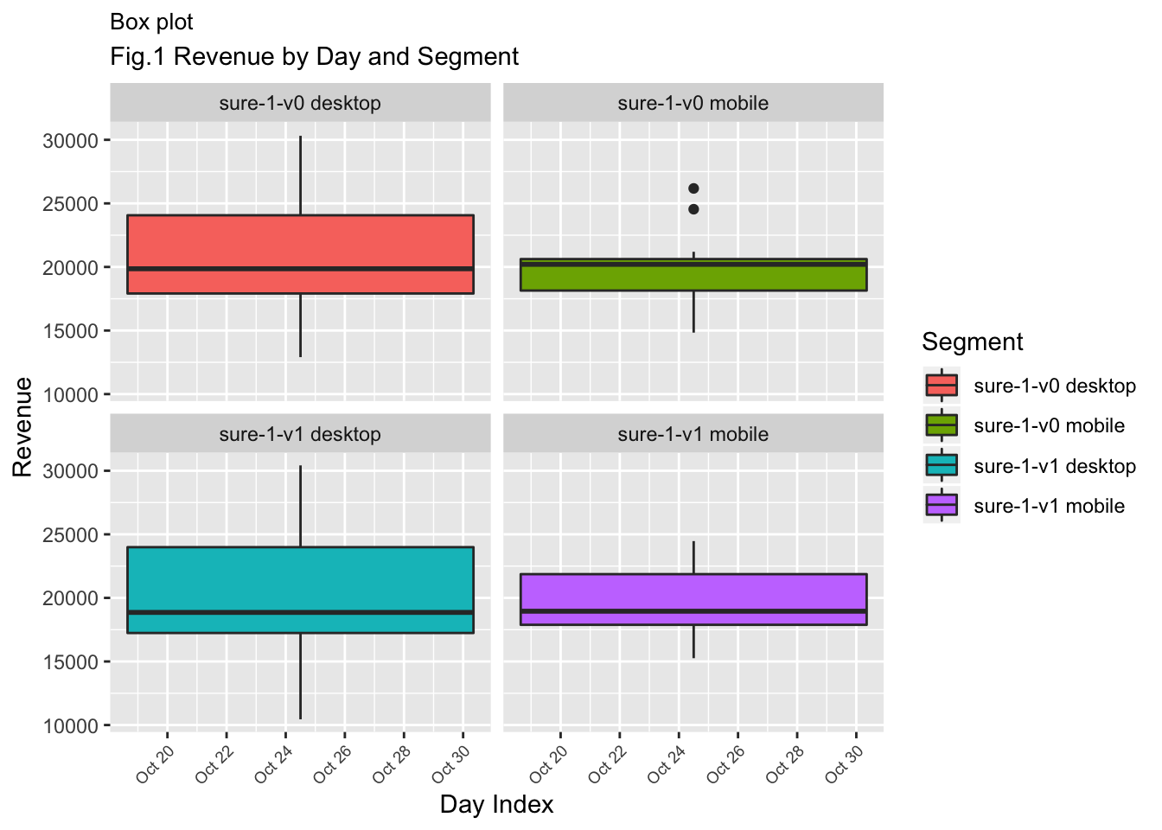

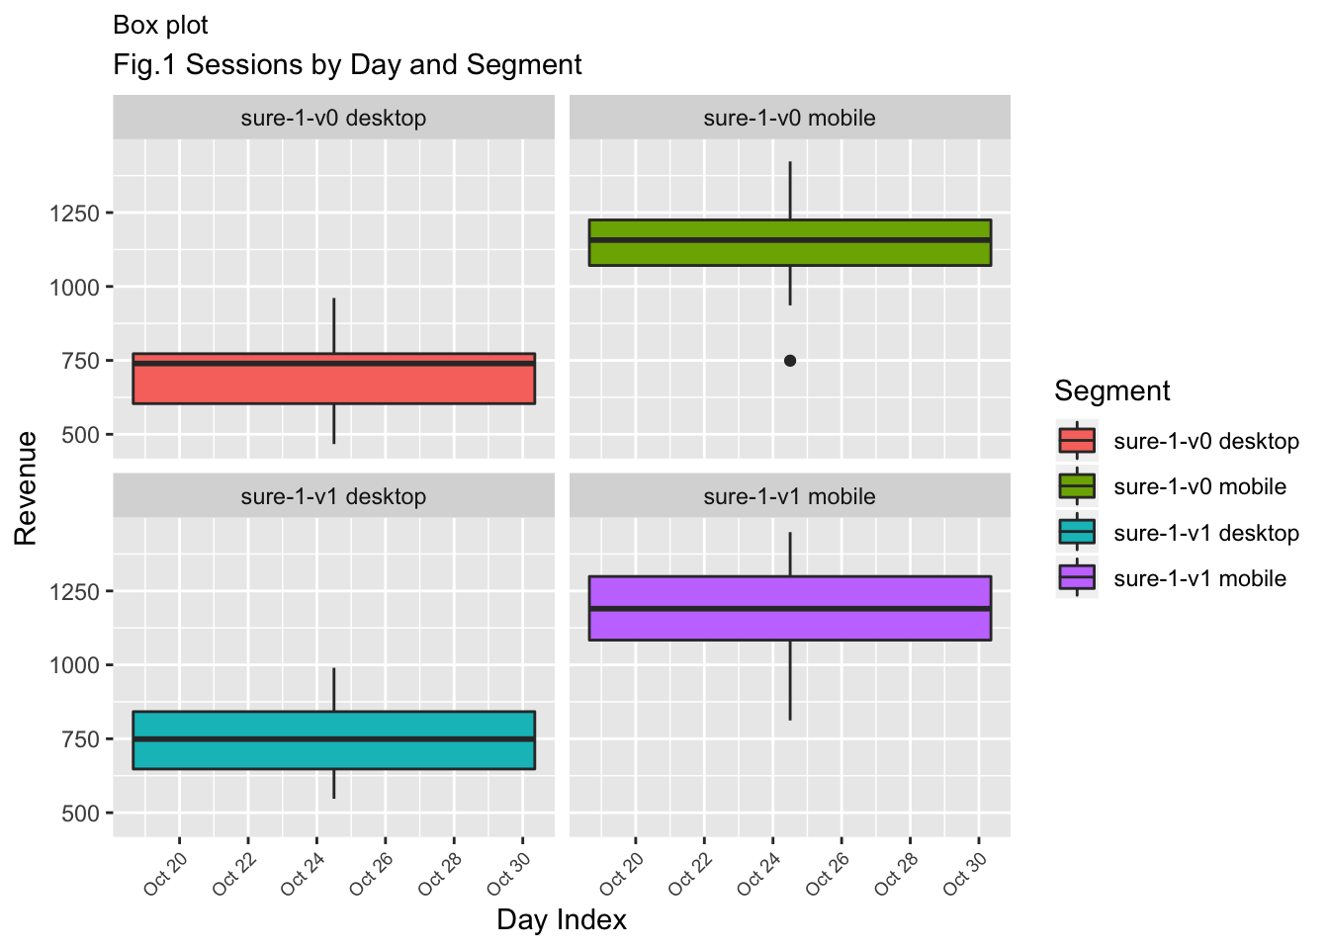

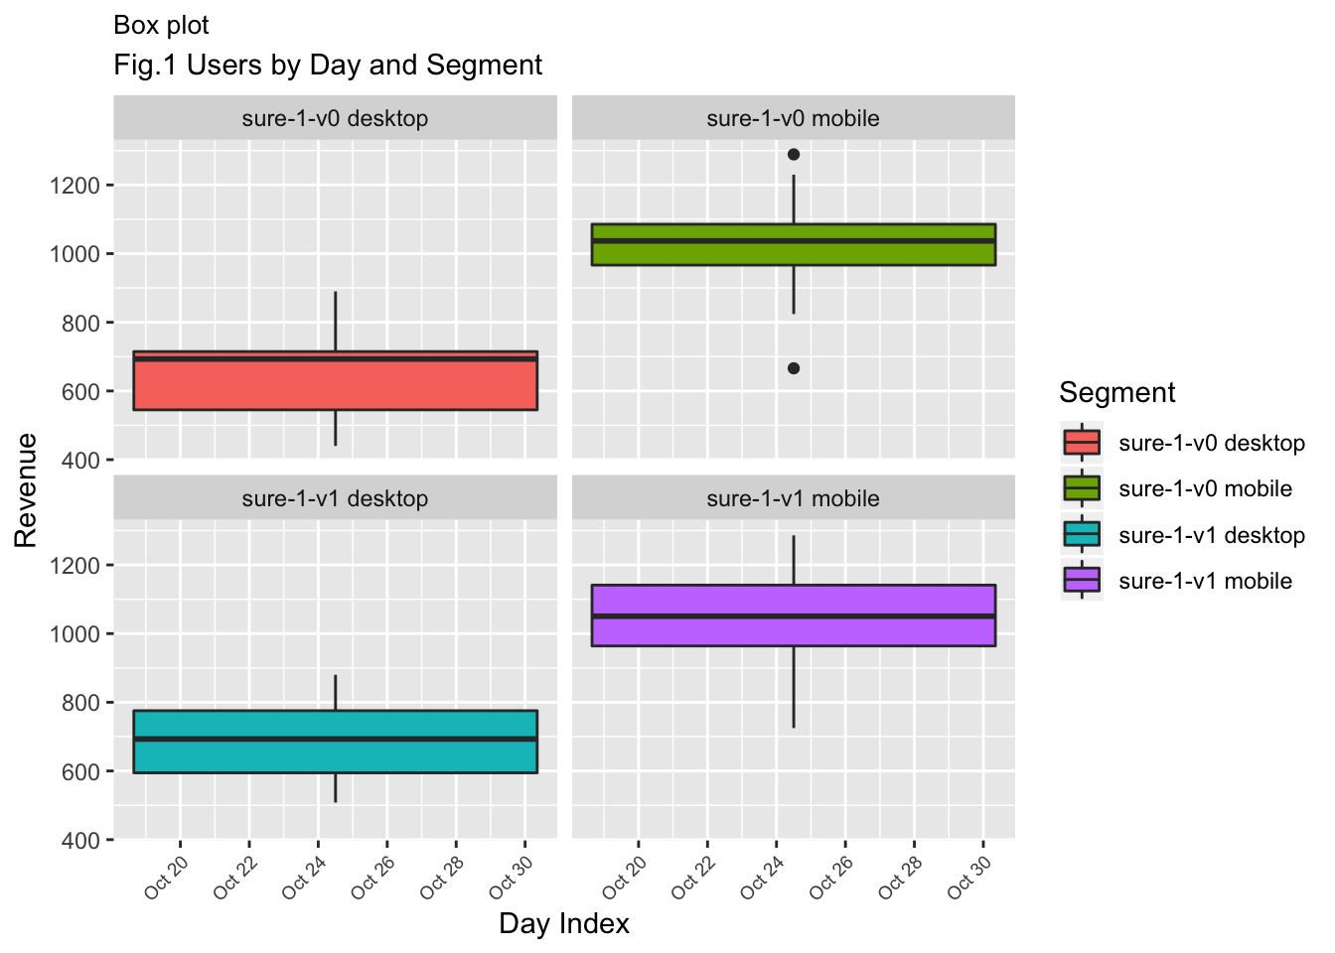

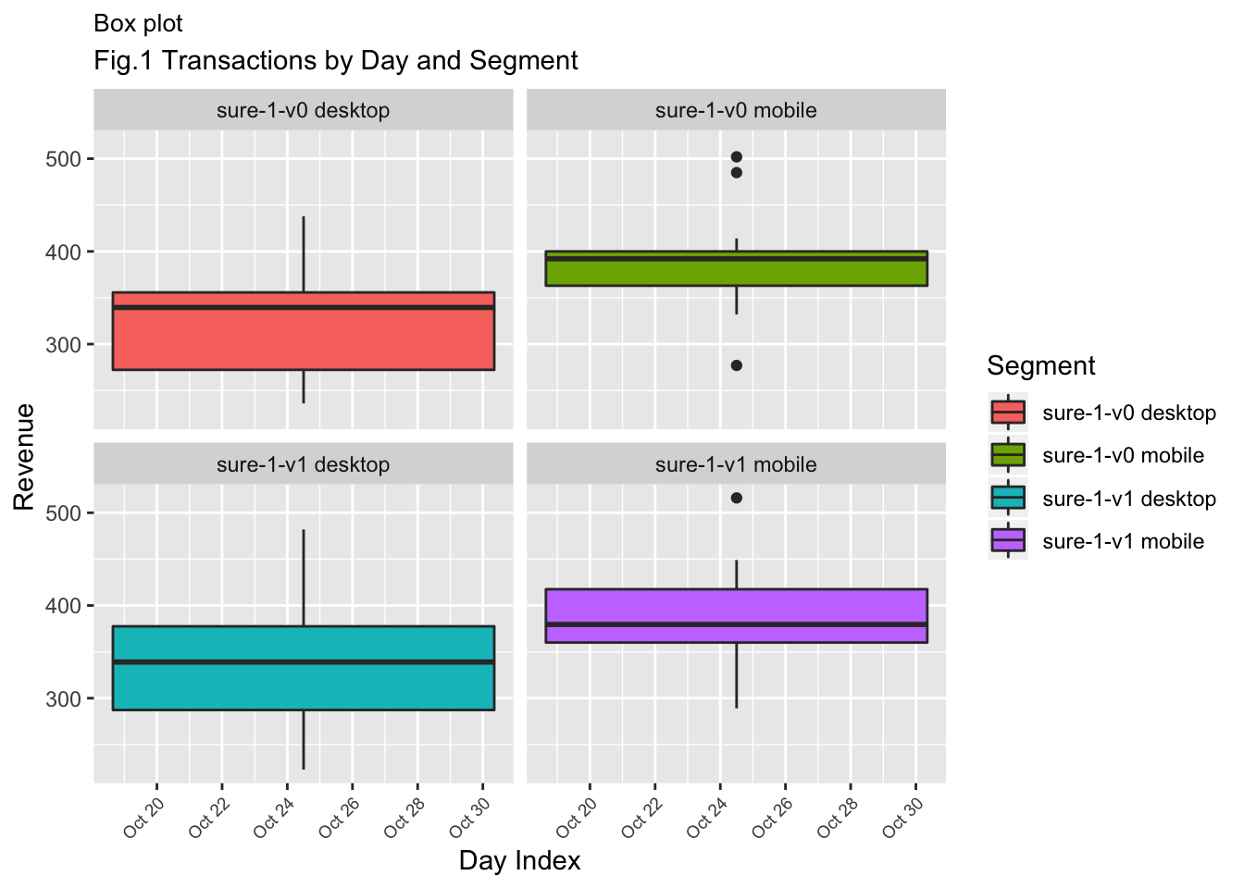

1. **T-test**

The t-test is an inferential statistics for Potential outcome and shows that there is significant statistical difference in the group means between control and treatment groups. The Null hypothesis is that no difference in mean before and after the test.

Statistics is to determine if the data contains enough evidence to enable you to conclude that the computed statistics or relationships observed between variables can be interpreted as being true statements or if the results observed in your sample data are simply due to chance.

In surefoot data, the p values of the t-test on Revenue, Sessions, Transactions and Users are greater than 0.05 which shows that the Null is true and is accepted and confirms that there is no statistical difference in the group means between control and test group.

1. Welch Two Sample t-test

**data: control_mobile_Users_01 and test_mobile_Users_01**

t = -0.17751, df = 25.999, **p-value = 0.8605**

alternative hypothesis: true difference in means is not equal to 0

95 percent confidence interval:

-132.9873 111.8445

sample estimates:

mean of x mean of y

1022.000 1032.571

1. Welch Two Sample t-test

**data: control_desktop_Users_01 and test_desktop_Users_01**

t = -0.79108, df = 25.549, **p-value = 0.4362**

alternative hypothesis: true difference in means is not equal to 0

95 percent confidence interval:

-138.36660 61.50946

sample estimates:

mean of x mean of y

659.0000 697.4286

1. Welch Two Sample t-test

**data: control_desktop_Sessions_01 and test_desktop_Sessions_01**

t = -0.90533, df = 25.892, **p-value = 0.3736**

alternative hypothesis: true difference in means is not equal to 0

95 percent confidence interval:

-158.40716 61.55002

sample estimates:

mean of x mean of y

710.5714 759.0000

1. Welch Two Sample t-test

**data: control_mobile_Sessions_01 and test_mobile_Sessions_01**

t = -0.27524, df = 25.922, **p-value = 0.7853**

alternative hypothesis: true difference in means is not equal to 0

95 percent confidence interval:

-156.6814 119.6814

sample estimates:

mean of x mean of y

1149.786 1168.286

1. Welch Two Sample t-test

**data: control_mobile_Txn_01 and test_mobile_Txn_01**

t = 0.18596, df = 25.952, **p-value = 0.8539**

alternative hypothesis: true difference in means is not equal to 0

95 percent confidence interval:

-40.93623 49.07908

sample estimates:

mean of x mean of y

389.1429 385.0714

1. Welch Two Sample t-test

**data: control_desktop_Txn_01 and test_desktop_Txn_01**

t = -0.48019, df = 25.658, **p-value = 0.6352**

alternative hypothesis: true difference in means is not equal to 0

95 percent confidence interval:

-61.13720 37.99435

sample estimates:

mean of x mean of y

324.7143 336.2857

1. Welch Two Sample t-test

**data: control_desktop_revenue_01 and test_desktop_revenue_01**

t = 0.36736, df = 25.791, **p-value = 0.7163**

alternative hypothesis: true difference in means is not equal to 0

95 percent confidence interval:

-3255.699 4671.959

sample estimates:

mean of x mean of y

20819.64 20111.51

1. Welch Two Sample t-test

**data: control_mobile_revenue_01 and test_mobile_revenue_01**

t = 0.46003, df = 25.992, **p-value = 0.6493**

alternative hypothesis: true difference in means is not equal to 0

95 percent confidence interval:

-1718.724 2709.814

sample estimates:

mean of x mean of y

20036.94 19541.40

**Deliverable 3**

Since there is no statistically significant difference in Revenue or Users or Sessions or Transactions between the control and test period for both desktop and mobile device for the Days Index, the recommendation is to proceed with the control variation.